**Lab Exercise 8- DHT Sensor with Arduino**

In this lab, we will interface a **DHT22** sensor (used for temperature and humidity measurement) with an Arduino and display the sensor data on the serial monitor.

**Components Required:**

* 1 x Arduino Uno
* 1 x DHT11 or DHT22 Sensor
* Jumper wires
* Breadboard

**Circuit Diagram:**

* **DHT22 Pin Configuration**:
  + **Pin 1 (VCC)**: Connect to the 5V pin of Arduino.
  + **Pin 2 (Data)**: Connect to digital pin 2 of Arduino (you can choose any available digital pin).
  + **Pin 3 (NC)**: No connection (leave it open).
  + **Pin 4 (GND)**: Connect to the GND of Arduino.

If you are using a DHT22 sensor, connect a **10kΩ resistor** between the **VCC** and **Data** pin to act as a pull-up resistor.

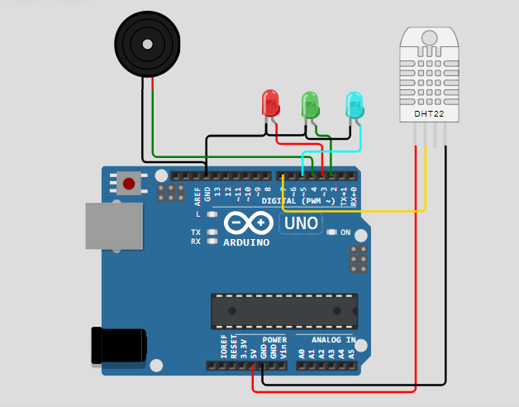

**Arduino Code:**

#include <DHT.h>

#define LEDGreen  2

#define LEDRed    3

#define LEDBlue 5

#define Buzzer    4

#define DHT_PIN   7

#define DHT_TYPE  DHT22

#define sensorMIN  0

#define sensorMAX  512

#define Threshold  300

DHT dht(DHT_PIN,DHT_TYPE);

int value = 0 ; //variable to store the sensor value

int level = 0 ; //variable to store the sensor level

void setup() {

  // put your setup code here, to run once:

**Serial**.begin(9600); //output using serial

  pinMode(Buzzer, OUTPUT);

  pinMode(LEDGreen, OUTPUT);

  pinMode(LEDRed, OUTPUT);

  pinMode(LEDBlue, OUTPUT);

  digitalWrite(LEDGreen, LOW);

  digitalWrite(LEDRed, LOW);

  digitalWrite(LEDBlue, LOW);

  dht.begin();

}

void loop() {

  // put your main code here, to run repeatedly:

  noTone(Buzzer);

  digitalWrite(LEDGreen, LOW);

  digitalWrite(LEDRed, LOW);

  digitalWrite(LEDBlue, LOW);

  value = analogRead(DHT_PIN);

  digitalWrite(DHT_PIN, LOW);

  delay(500);

  float temperature = dht.readTemperature();

  float humidity = dht.readHumidity();

  if (temperature < 25 && humidity < 25) {

    noTone(Buzzer);

    digitalWrite(LEDGreen, HIGH);

    digitalWrite(LEDRed, LOW);

    digitalWrite(LEDBlue, LOW);

**Serial**.print("ATTENTION!!! LOW TEMPERATURE");

  }

  else if (temperature > 35 || humidity >35) {

    tone(Buzzer,500);

    digitalWrite(LEDGreen, LOW);

    digitalWrite(LEDRed, HIGH);

    digitalWrite(LEDBlue, LOW);

**Serial**.print("ATTENTION!!! TEMPERATURE TOO HIGH ");

  }

  else if (temperature > 40 || humidity < 40) {

    tone(Buzzer,800);

    digitalWrite(LEDGreen, LOW);

    digitalWrite(LEDRed, LOW);

    digitalWrite(LEDBlue, HIGH);

  }

  else

    level = map(value,sensorMIN,sensorMAX,0,10); // to be 10 levels

**Serial**.print("TEMPERATURE DETECTED: ");

**Serial**.print(temperature);

**Serial**.print(" HUMIDITY: ");

**Serial**.println(humidity);

}

**Testing and Results:**

1. Upload the code to the Arduino board.
2. Open the Serial Monitor (Tools > Serial Monitor) and set the baud rate to **9600**.
3. You should see the temperature and humidity values being printed every 2 seconds.

**Expected Output on the Serial Monitor:**

yaml

Copy code

DHT Sensor reading initialized

Humidity: 45.30 % Temperature: 26.50 °C

Humidity: 45.50 % Temperature: 26.60 °C

Humidity: 45.10 % Temperature: 26.40 °C

...

**Conclusion:**

In this lab exercise, you successfully interfaced a **DHT sensor** (DHT11 or DHT22) with an Arduino to measure and display the temperature and humidity. This simple setup is useful for IoT projects related to environmental monitoring, weather stations, and smart homes.